Interim Report

Carim Akeju, Erik Jeny, Callum Nicholson

# Introduction & Outline of Requirements

The brief is to develop a piece of software to translate to/from English to another language.

As stated in the brief, we are required to do the following:

* Create a dictionary with an appropriate data structure. We are going to use a Trie Tree (also known as a digital tree or prefix tree), where nodes are not associated with a key, but nodes are defined by a single character. Words are built by traversing along individual letters and the translation is obtained at the final node required.
* Translate individual words.
* Translate phrases. We have opted to prioritise phrases during translation.
* Load a file and apply a translation.
* Allow the user to add words to the dictionary.
* Allow the user to remove words from the dictionary.
* Allow the user to display the dictionary.
* Produce a standalone executable.

We can also:

* Produce a Graphical User Interface
* Include methods of translating grammar correctly.
* Include more languages.
* Optimise our methods of searching and comparing data (for example, we aim to optimise the Trie Tree by not storing all 26 letters as a node, and only creating them when they are needed).

# User Interface Mockups

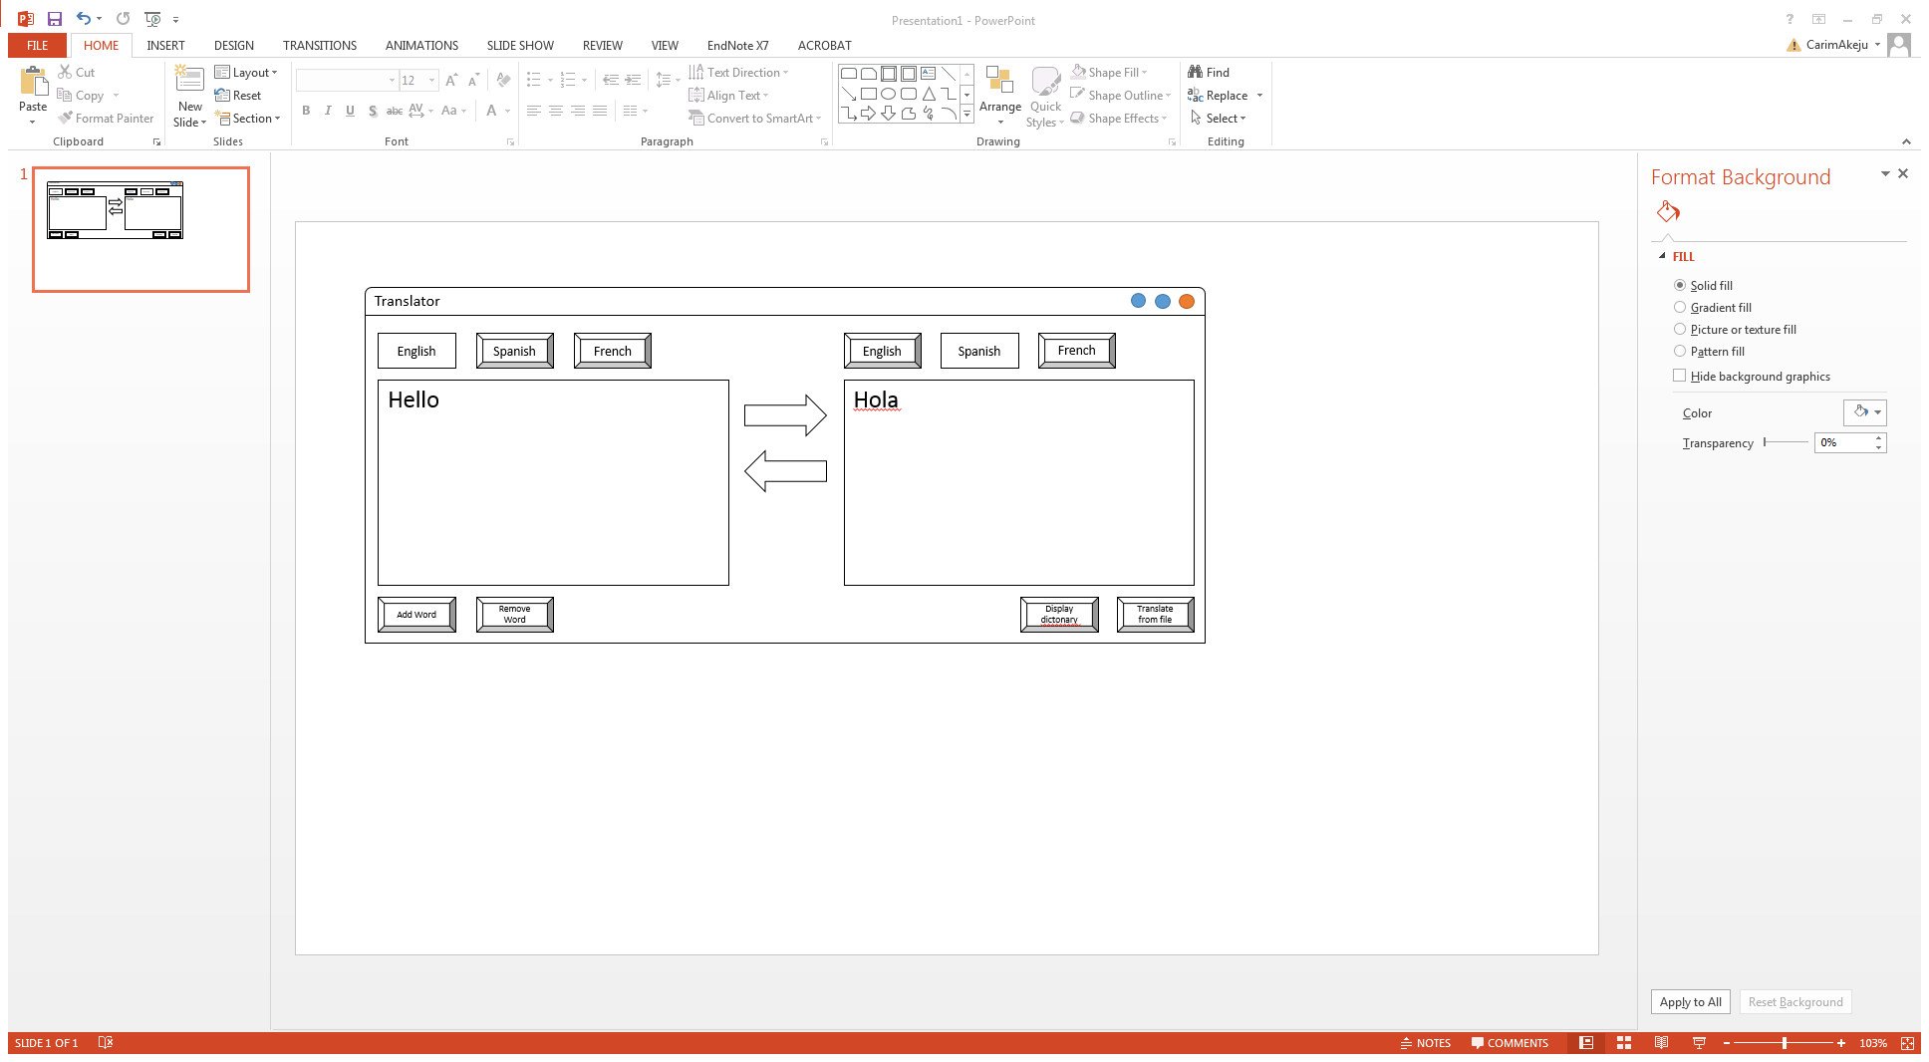

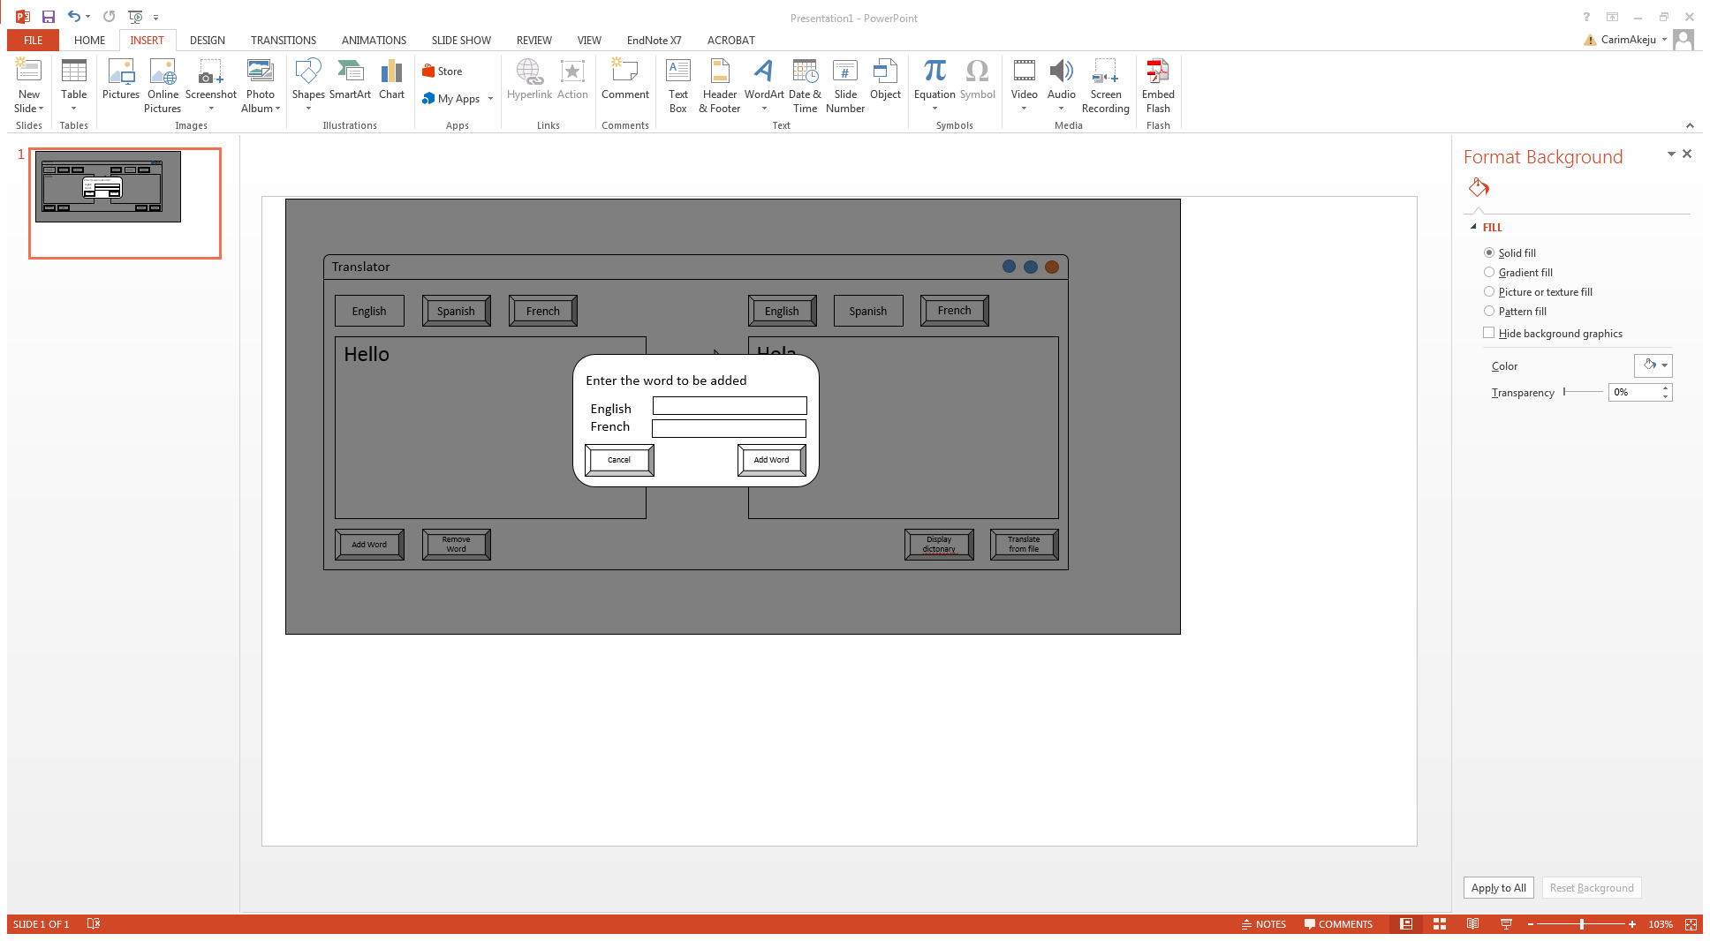

# Flow charts

## Main Processes

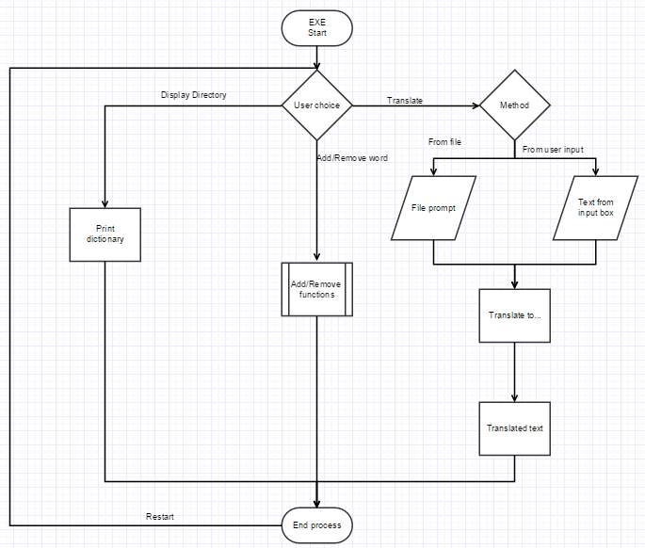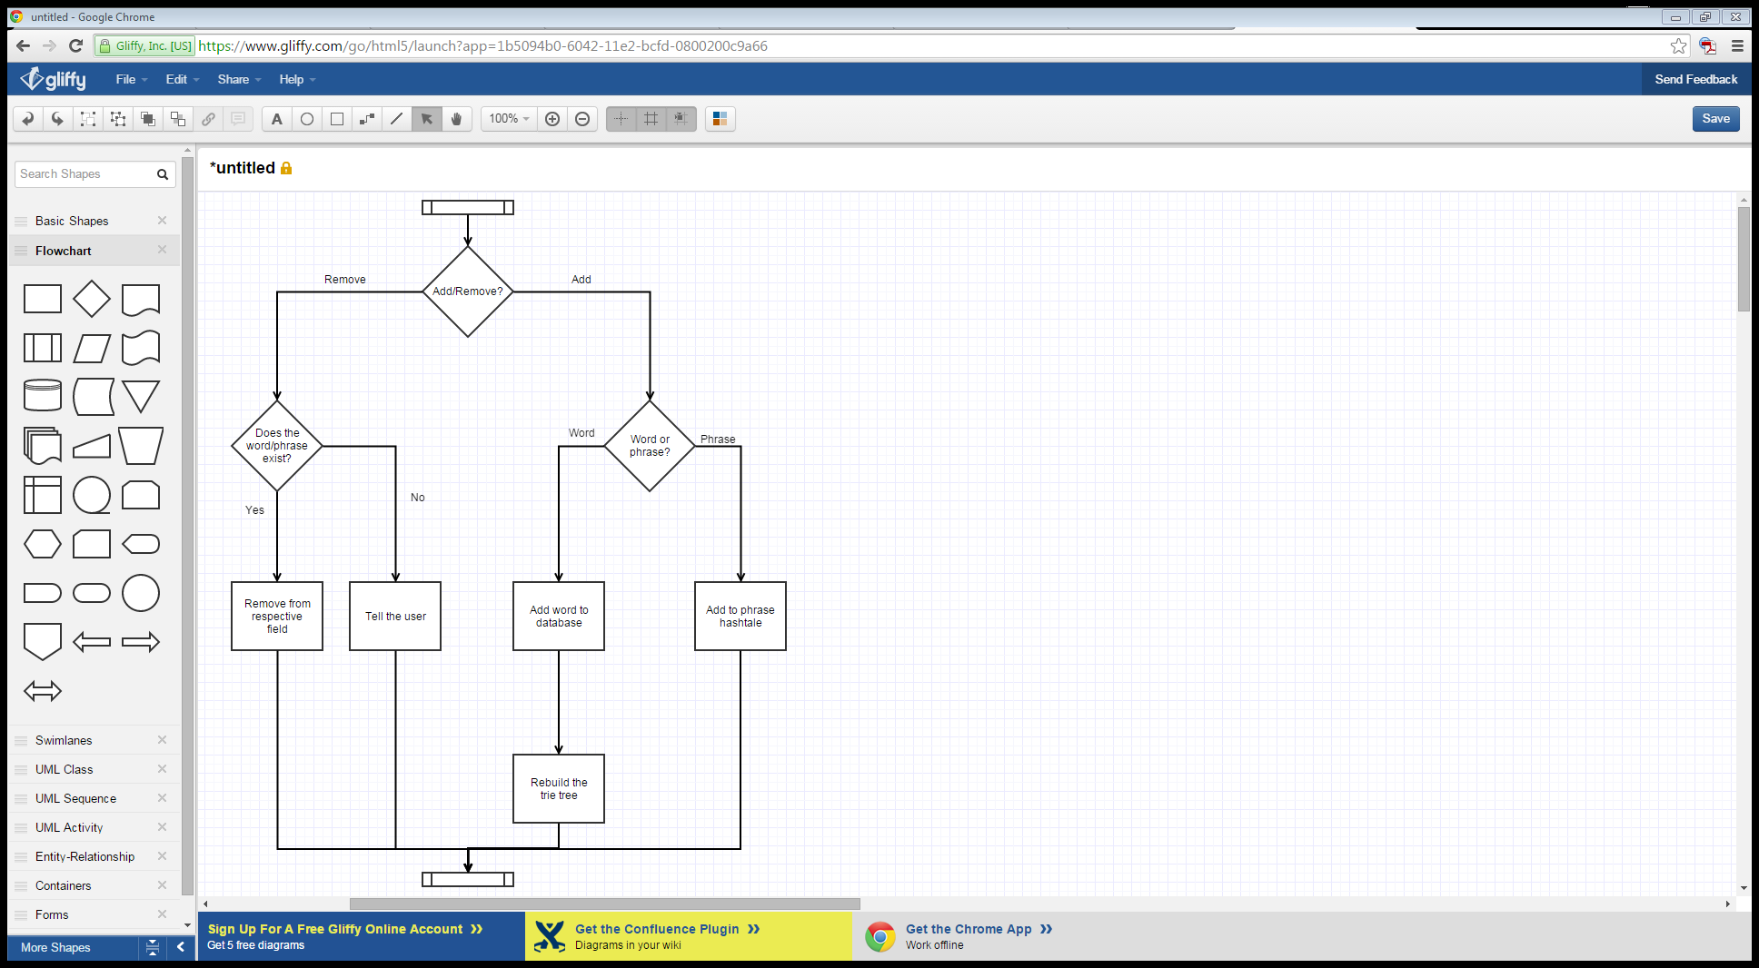

## Adding a Word

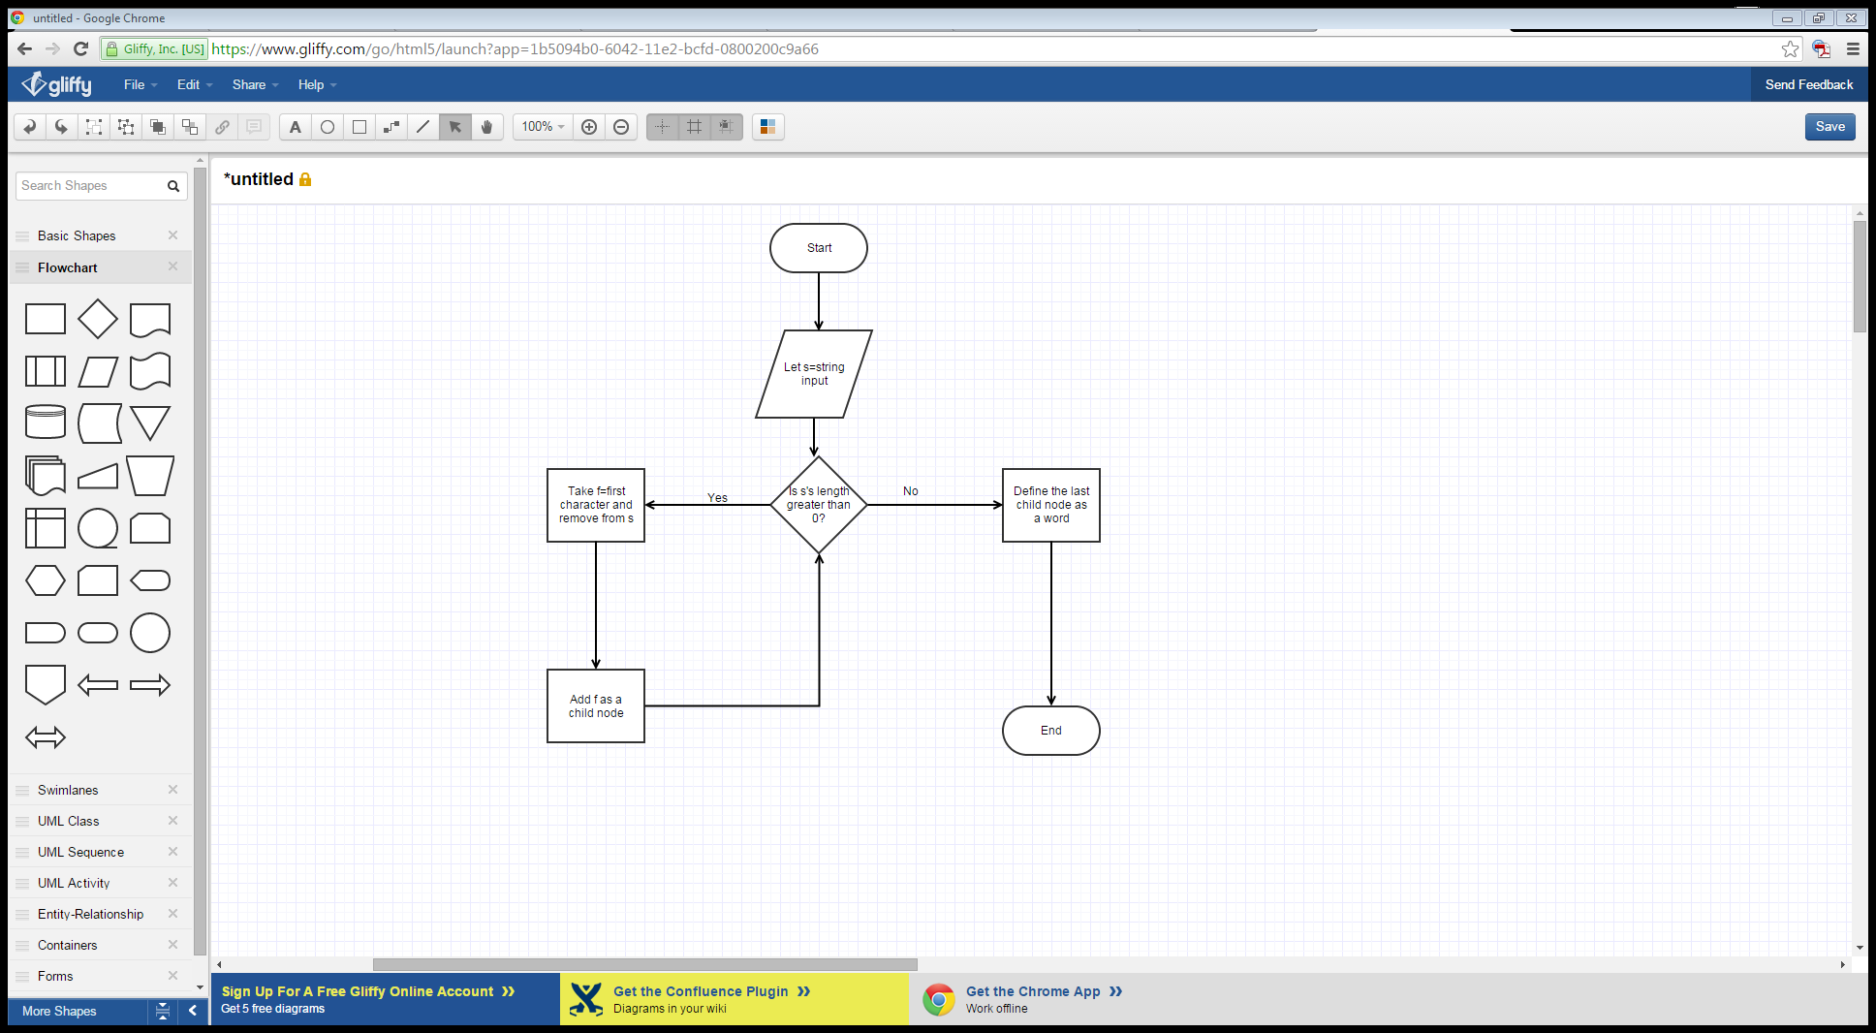

## Finding a Word

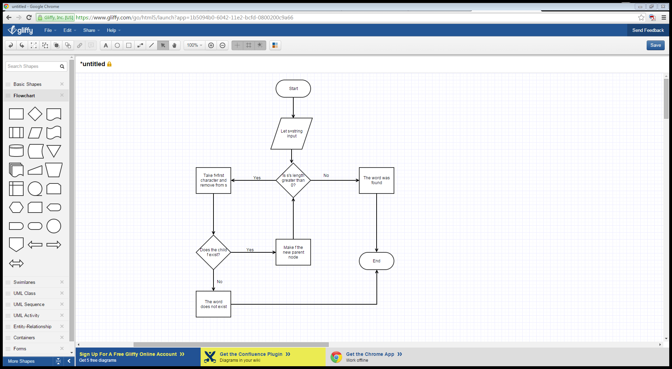

## Displaying the Dictionary

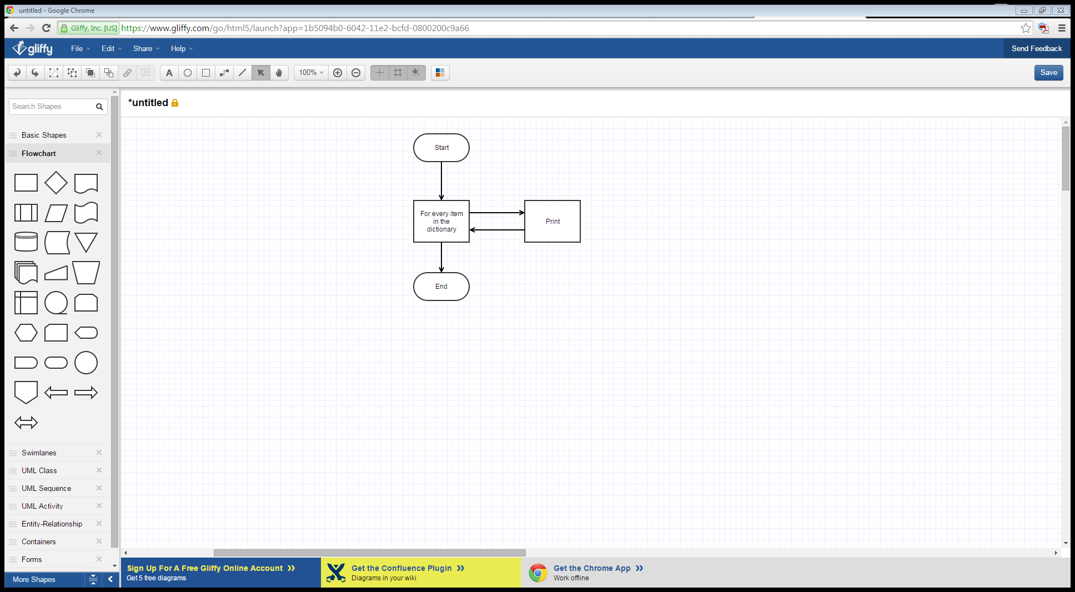

## Test plans and results

## Words

|  |  |  |  |  |  |
| --- | --- | --- | --- | --- | --- |
| Word | Starting Language | Target Language | Expected Outcome | Actual  Outcome | Comments |
|  |  |  |  |  |  |
|  |  |  |  |  |  |
|  |  |  |  |  |  |
|  |  |  |  |  |  |
|  |  |  |  |  |  |
|  |  |  |  |  |  |
|  |  |  |  |  |  |
|  |  |  |  |  |  |
|  |  |  |  |  |  |

## Phrases

|  |  |  |  |  |  |
| --- | --- | --- | --- | --- | --- |
| Phrase | Starting Language | Target Language | Expected Outcome | Actual  Outcome | Comments |
| “What time is it?” | English | French |  |  |  |
| “What time is it?” | English | Spanish |  |  |  |
| “What time is it?” | Spanish | English |  |  |  |
| “What time is it?” | French | English |  |  |  |
| “What time is it?” | Spanish | French |  |  |  |
| “Quelle heure est-il?” | French | Spanish |  |  |  |
| “Quelle heure est-il?” | French | English |  |  |  |
| “Gobeldy Goop “ | English | Spanish |  |  |  |
| “ “ | French | Spanish |  |  |  |

## Translating a file

## Evaluation